PROJECT REPORT

ESTIMATION OF BUSINESS EXPENSES

# 1. INTRODUCTION

## 1.1 OVERVIEW

The purpose of this project report is to estimate the business expenses associated with the establishment and operation of [Your Business Name]. This report provides a detailed breakdown of start-up and operating expenses, helping stakeholders understand the financial requirements of the business.

Financial planning is a cornerstone of successful business management. To achieve sustainable growth and profitability, it is imperative for businesses, whether small start-ups or large corporations, to accurately estimate their expenses. This process of expense estimation plays a vital role in guiding decision-making, ensuring budgetary discipline, and ultimately determining the financial health of the enterprise.

## 1.2 PURPOSE

The purpose of estimating business expenses is multifaceted and plays a fundamental role in the financial planning and management of any business. Here are the primary purposes of estimating business expenses:

Expense estimation is a critical step in creating a budget for a business. Accurate expense estimation is essential for developing comprehensive financial plans. By estimating expenses, businesses can determine where their financial resources need to be allocated. Expense estimation allows businesses to identify potential financial risks and uncertainties. Once expenses are estimated and budgeted, they serve as a benchmark for performance tracking. For businesses seeking external funding from investors or lenders, accurate expense estimates demonstrate financial acumen and transparency. Expense estimation encourages businesses to evaluate their operations critically. Estimating business expenses is crucial for tax planning.

# 2. PROBLEM DEFINITION & DESIGN THINKING

## 2.1 EMPATHY MAP

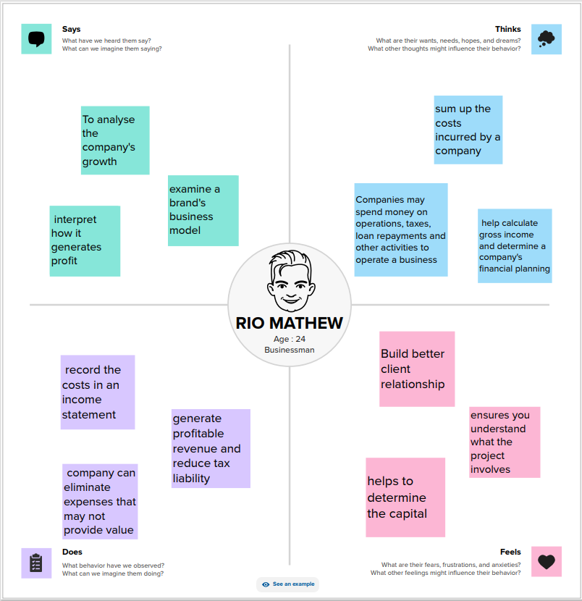

## 2.2 IDEATION & BRAINSTORMING MAP

# 3. RESULT

DASHBOARD 2

DASHBOARD 1

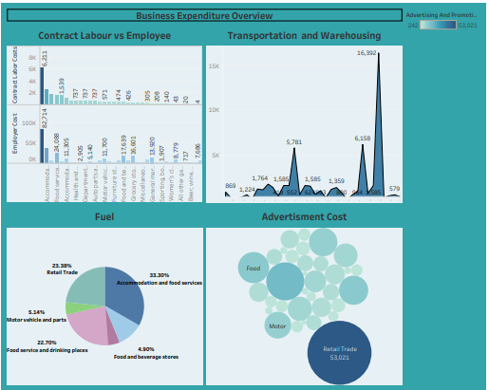

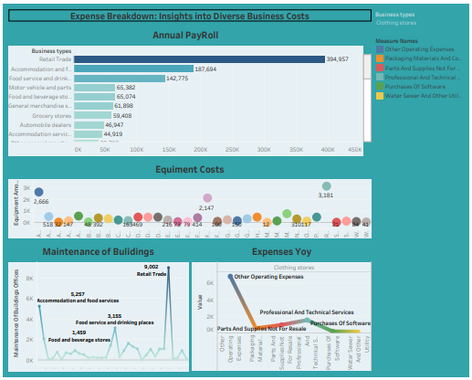

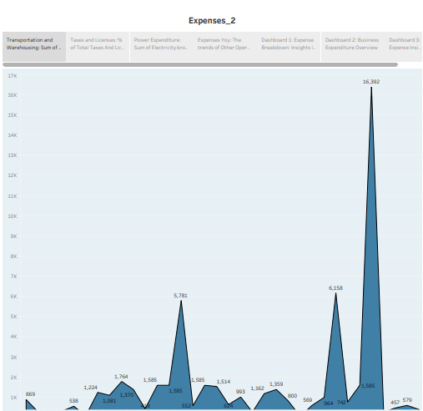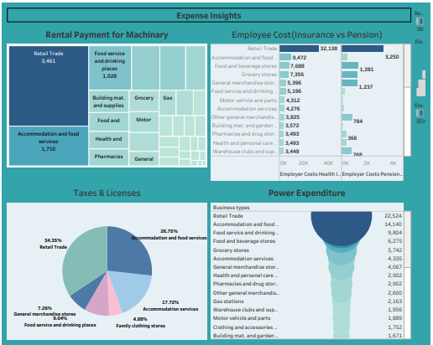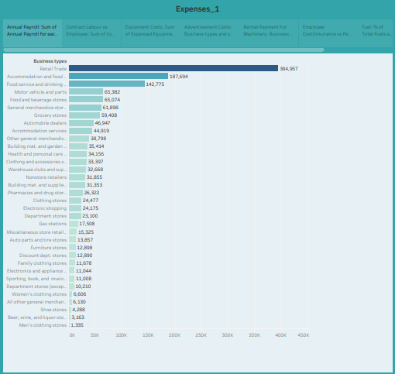

STORY 2

STORY 1

DASHBOARD 3

# 4. ADVANTAGES AND DISADVANTAGES

## 4.1 Advantages of Estimating Business Expenses:

1. **Budgeting:** Expense estimation is essential for creating a budget, which serves as a financial roadmap. A well-structured budget helps allocate resources efficiently and sets financial goals.
2. **Resource Allocation:** Estimation allows businesses to allocate resources effectively, ensuring that essential areas receive adequate funding while avoiding overspending in non-essential areas.
3. **Financial Planning:** It aids in developing comprehensive financial plans, aligning financial strategies with short-term and long-term goals.
4. **Risk Mitigation:** Expense estimation helps identify potential financial risks and uncertainties, enabling businesses to plan for contingencies and build financial resilience.
5. **Performance Tracking:** Estimates serve as benchmarks for tracking financial performance. Comparing actual expenses to estimated expenses helps monitor financial health and take corrective actions when necessary.
6. **Investor and Lender Confidence:** Accurate estimates demonstrate financial responsibility to investors and lenders, fostering trust and increasing the likelihood of external funding.
7. **Operational Efficiency:** Estimation encourages businesses to evaluate operations critically, identify opportunities for cost reduction, and optimize processes.
8. **Tax Planning:** It is crucial for calculating tax liabilities accurately, taking advantage of available deductions, and ensuring compliance with tax laws.
9. **Resource Management:** Helps manage resources efficiently, especially in areas like staffing and inventory management.
10. **Long-Term Sustainability:** Prevents financial crises by ensuring funds are available to cover necessary costs and contingencies, contributing to long-term sustainability.

## 4.2 Disadvantages of Estimating Business Expenses:

1. **Inaccuracy:** Expense estimates are inherently based on assumptions and historical data, making them subject to inaccuracies. Unexpected expenses or changes in market conditions can lead to discrepancies.
2. **Complexity:** Estimating expenses can be a complex process, especially for businesses with diverse operations and markets. It requires careful analysis and research.
3. **Time-Consuming:** Developing accurate expense estimates can be time-consuming, as it involves gathering data, making calculations, and considering various scenarios.
4. **External Factors:** Businesses may have limited control over external factors, such as economic conditions, market fluctuations, or regulatory changes, which can affect the accuracy of expense estimates.
5. **Overly Conservative Estimates:** To mitigate risk, businesses may tend to overestimate expenses, which can lead to unnecessary resource allocation and reduced profitability.
6. **Lack of Flexibility:** Over-reliance on estimates may lead to a lack of flexibility when adapting to changing circumstances or seizing unexpected opportunities.
7. **Resource Constraints:** Smaller businesses may lack the resources or expertise to conduct thorough expense estimation, potentially leading to less accurate estimates.
8. **Overlooked Expenses:** There is a risk of overlooking certain expenses, particularly those that are less obvious or variable in nature.
9. **Overemphasis on Cost Reduction:** Focusing too much on cost reduction can lead to neglect of investment opportunities that may be beneficial for the business's growth.

Top of Form

# 5. APPLICATION

An estimate gives information about the items or services by the seller to the buyer with the predicted prices.

A customer usually requests estimates from various sellers or service providers to select the best offer that works for him in a particular market. It is allowed due to the nature of an estimate that it does not bind the parties involved in it.

It is essential for businesses, especially MSMEs, to stay competitive and attract potential buyers, customers or clients. If the estimate is appealing enough, it helps in securing a deal or sale. It enables the buyers to know the average price in the market for a particular product or service. Further, it allows sellers to know their competitors’ price quotes and how much they are willing to charge.

The following are the benefits of using estimates-

* To get quotes in a market for a particular product or service.
* Estimates represent sales orders.
* Allows prepayments or deposits or retainers.
* Acts as a document for collecting the approval of the buyer to go ahead with an order.
* Promotes calculation of price estimates for a job or project.
* A change in any of the details does not require revision of the estimate or is not a final sales invoice.

The use of estimates can be seen in different situations and across Indian industries. Estimates are popular among businesses of all sizes and supply chain levels, such as manufacturers, wholesalers, retailers, or other intermediaries. However, estimates are most commonly used in project-based jobs such as construction, design, contracting, etc.

When the seller issues an estimate, the potential customer may either accept the estimate, negotiate the prices and scope of supply, or even decide not to go ahead with the transaction. If the potential customer agrees with the estimate, he will create a purchase order. The seller will supply goods or services per the purchase order and issue a standard or tax invoice.

# 6. CONCLUSION

The estimation of business expenses is a valuable document that outlines the various costs associated with starting and operating a business. It provides a comprehensive overview of the financial requirements, helping stakeholders understand the budget needed to launch and sustain the business.

The estimation of business expenses is a critical component of financial planning and management. It serves as the foundation for budgeting, resource allocation, and risk mitigation. Accurate estimation empowers businesses to make informed decisions, demonstrate financial responsibility to stakeholders, and ultimately achieve long-term financial success. Businesses that invest time and effort in this process are better equipped to navigate the complexities of today's dynamic business landscape and secure a prosperous future.

While estimating business expenses offers numerous advantages in terms of financial planning, resource allocation, and risk mitigation, it also comes with potential disadvantages related to accuracy, complexity, and inflexibility. Businesses should approach expense estimation as a dynamic process that requires on-going monitoring and adjustment to ensure that it aligns with the business's evolving needs and market conditions.

Expense estimation is a versatile and essential tool for businesses. It empowers them to make informed financial decisions, allocate resources efficiently, manage risks, and plan for future growth and sustainability. Accurate and well-thought-out expense estimates are invaluable for achieving both short-term and long-term business objectives.

In conclusion, the estimation of business expenses is a foundational and multifaceted practice that underpins sound financial planning, management, and decision-making within an organization. It is a process that involves forecasting and quantifying various costs associated with running a business, both during its startup phase and ongoing operations. The importance of expense estimation cannot be overstated, as it serves several critical functions that contribute to the overall financial health and success of a business.

In today's rapidly evolving business landscape, accurate expense estimation is not just a financial exercise but a strategic imperative. It empowers businesses to adapt to economic uncertainties, seize growth opportunities, and achieve long-term sustainability. By embracing the practice of estimating business expenses with diligence and precision, organizations can navigate the complexities of the business world with confidence, ensuring their financial well-being and future success.

# 7. FUTURE SCOPE

The future scope of estimation of business expenses holds significant potential and is likely to continue evolving in response to changing business environments, technology advancements, and global economic trends. Here are some key aspects of the future scope of this practice:

1. **Advanced Data Analytics:** As businesses collect more data and employ sophisticated analytics tools, the accuracy and granularity of expense estimation will improve. Machine learning and artificial intelligence can help businesses analyse historical expense data to make more accurate predictions and optimize resource allocation.

2. **Real-Time Expense Tracking:** The future will likely see a shift toward real-time expense tracking and forecasting. Businesses will have access to up-to-the-minute financial data, allowing for more agile decision-making and better cost control.

3. **Predictive Analytics:** Predictive analytics will become more prevalent in expense estimation. Businesses can use predictive models to anticipate future expenses based on various factors, including market conditions, customer behaviour, and economic trends.

4. **Integration with Financial Technology (Fin-tech):** The integration of expense estimation tools with fin-tech solutions will streamline financial management. Businesses can use fin-tech platforms to automate expense tracking, categorization, and reporting, reducing manual effort and errors.

5. **Block chain for Expense Verification:** Block chain technology can enhance transparency and trust in expense reporting. Businesses can use block chain to securely verify transactions and expenses, reducing the risk of fraud and inaccuracies.

In summary, the future scope of estimation of business expenses will be marked by increased automation, data-driven decision-making, integration with emerging technologies, and a focus on sustainability, risk management, and compliance. Businesses that adapt to these evolving trends and leverage advanced tools and strategies for expense estimation will be better positioned to navigate the complexities of the business landscape and achieve financial success.